Day 39 Apache Spark Introduction & Architecture.
What is Apache Spark – Unified Engine for handling Large-scale data Analytics.
Why
How to use it.

Spark Architecture.

Components/Terminologies used in Apache Spark.

Data is new oil.

Social Media – Large volume data.

Handling large amount of data in a shorter period of time.

Hadoop is created. HDFS (Hadoop Distributed File system), Map Reduce
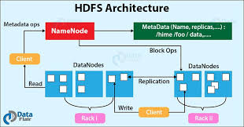

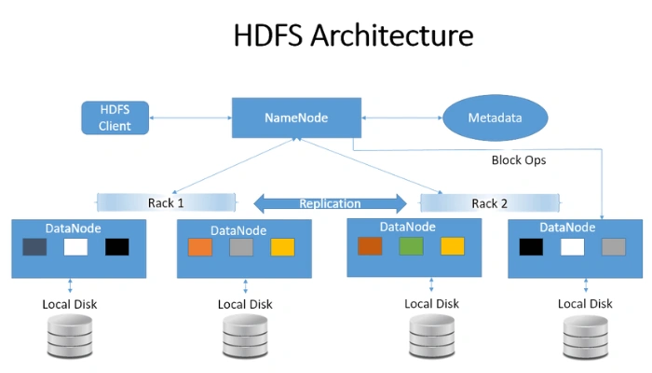
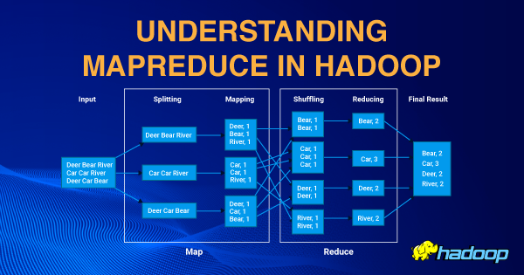

Hadoop works on Disk level (It stores and process the data by reading and writing it from the hard disk, rack) – Speed is very less.

Spark – Will help to do operations on large volume of data (big-data) directly from memory (RAM) – Speed 10x-100x faster.

Spark Core + Spark ML lib + Spark Streaming + Spark SQL

API support – It supports all major programming lang (Java, Python, R, Node, SQL etc.,)
For Python – pyspark.
Spark is created using scala lang.
5000 – Chapathi. Single chef. – 5 hours.
5000 – chappathi. 5 chef. – 1 hours
Dataframe, Dataset

Apache Spark is a multi-language engine for executing data engineering, data science, and machine learning on single-node machines or clusters.

Apache spark is a open source.
https://github.com/apache/spark

Installing and configuring Spark in Windows 11.
Spark download -- https://dlcdn.apache.org/spark/spark-3.5.7/spark-3.5.7-bin-hadoop3.tgz
Pre-requisites
- Hadoop
- HADOOP_HOME, SPARK_HOME – environment variables
SPARK_HOME = C:\spark-3.5.7-bin-hadoop3
HADOOP_HOME = C:\hadoop
Path= %path%;%SPARK_HOME%\bin; %HADOOP_HOME%\bin
- C:/Hadoop – create a bin folder and place winutlis.exe file – https://github.com/cdarlint/winutils/tree/master/hadoop-3.3.5/bin -- https://download-directory.github.io/
Spark Architecture.
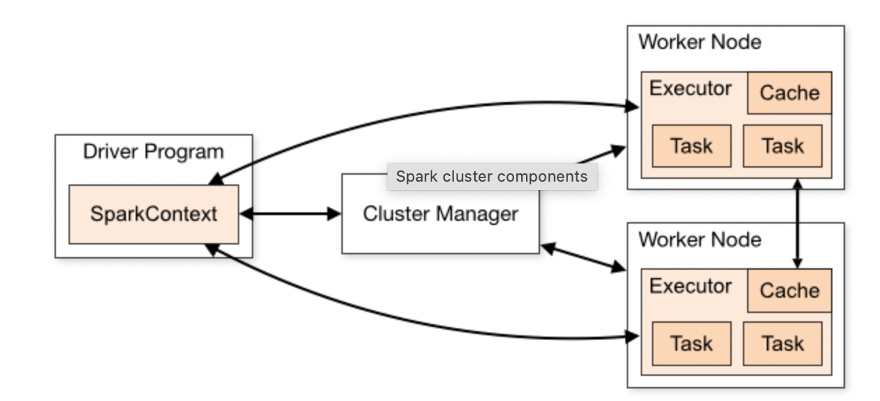

Spark Cluster – Combination of more than one computer. [Master & Slave – Driver (Process/Node) & Worker (Process/Node)

RDD – Resilient Distributed Dataset. – Collection of distributed data across multiple nodes in a Spark cluster.
DAG – Directed Acyclic Graph
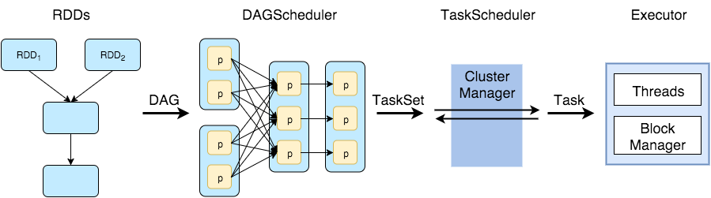

Data Engineering, Data Analytics, Big-Data Processing
ML – Machine Learning
SQL
Python
Spark Streaming
Spark Core.

Spark Session & Spark Context using Spark configuration.
Input data source
Process
Output.

Flat file data reading.

Create a Maven based Java Project in STS/Eclipse

<project xmlns="http://maven.apache.org/POM/4.0.0"
xmlns:xsi="http://www.w3.org/2001/XMLSchema-instance"
xsi:schemaLocation="http://maven.apache.org/POM/4.0.0 https://maven.apache.org/xsd/maven-4.0.0.xsd">
<modelVersion>4.0.0</modelVersion>
<groupId>com.example</groupId>
<artifactId>sparkdemo</artifactId>
<version>0.0.1-SNAPSHOT</version>

<properties>
<maven.compiler.source>17</maven.compiler.source>
<maven.compiler.target>17</maven.compiler.target>
<spark.version>3.5.0</spark.version>
<scala.binary.version>2.12</scala.binary.version>
</properties>

<dependencies>
<!-- Spark Core -->
<dependency>
<groupId>org.apache.spark</groupId>
<artifactId>spark-core_${scala.binary.version}</artifactId>
<version>${spark.version}</version>
</dependency>
<!-- Logging backend for Spark -->
<dependency>
<groupId>org.slf4j</groupId>
<artifactId>slf4j-simple</artifactId>
<version>2.0.9</version>
</dependency>

<!-- Spark SQL (optional, if you use DataFrames later) -->
<dependency>
<groupId>org.apache.spark</groupId>
<artifactId>spark-sql_${scala.binary.version}</artifactId>
<version>${spark.version}</version>
</dependency>
</dependencies>

<build>
<plugins>
<!-- Compiler plugin -->
<plugin>
<groupId>org.apache.maven.plugins</groupId>
<artifactId>maven-compiler-plugin</artifactId>
<version>3.11.0</version>
<configuration>
<source>${maven.compiler.source}</source>
<target>${maven.compiler.target}</target>
</configuration>
</plugin>

<!-- Shade plugin to build a fat JAR -->
<plugin>
<groupId>org.apache.maven.plugins</groupId>
<artifactId>maven-shade-plugin</artifactId>
<version>3.5.1</version>
<executions>
<execution>
<phase>package</phase>
<goals>
<goal>shade</goal>
</goals>
<configuration>
<transformers>
<transformer
implementation="org.apache.maven.plugins.shade.resource.ManifestResourceTransformer">
<mainClass>WordCount</mainClass>
</transformer>
</transformers>
</configuration>
</execution>
</executions>
</plugin>
</plugins>
</build>

</project>

